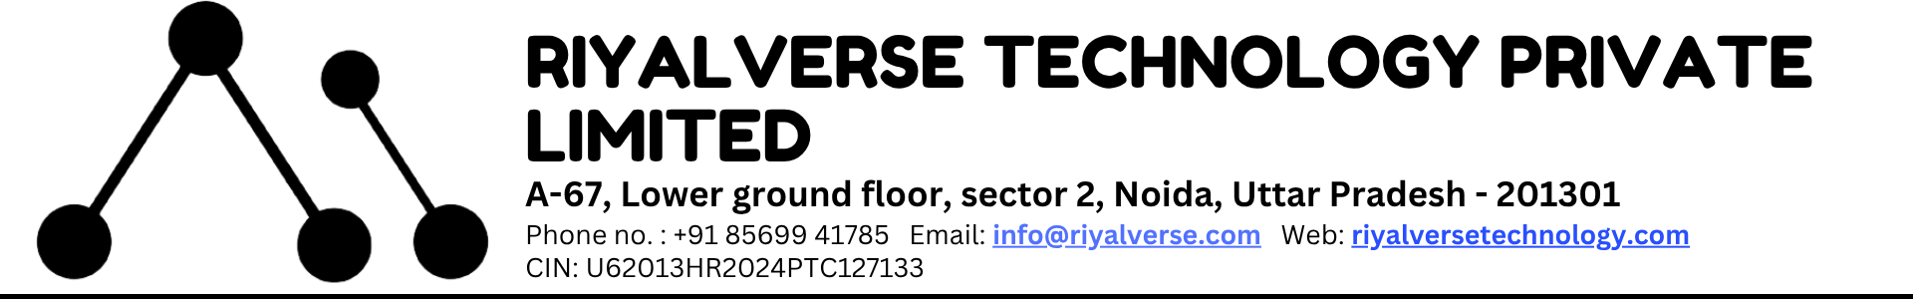

### **“PROJECT NAME”**

A Project Report submitted in partial fulfillment of the requirement For the award of degree of

***Supervised By Submitted By***

Mentor Name Student Name

CTO / CEO Roll no

RiyalVerse Technology Private Limited

**Acknowledgement**

The successful completion of this project would not have been possible without the invaluable guidance, support, and encouragement of many individuals.

I would like to express my deepest gratitude to **Mr. Ravi Shamra, Managing Director of RiyalVerse Technology Pvt. Ltd.**, for providing me the opportunity to work on this project and for creating an environment that fosters learning and innovation.

I am sincerely thankful to my project mentor **[Mentor Name]**, CEO/CTO at RiyalVerse Technology Pvt. Ltd., for their constant guidance, constructive feedback, and valuable insights throughout the development of this project. Their mentorship not only enhanced my technical skills but also helped me gain a deeper understanding of industry practices.

Finally, I would like to acknowledge the entire **RiyalVerse Technology Pvt. Ltd.** team for their encouragement, collaboration, and assistance during various stages of the project.

**Declaration**

I, **[Student Name]**, trainee at **RiyalVerse Technology Pvt. Ltd.**, hereby declare that the project titled **“[Project Name]”** has been completed by me during my internship/training period from **[Start Date] to [End Date]** under the guidance of **[Mentor Name]**, CEO/CTO, RiyalVerse Technology Pvt. Ltd.

I further declare that the work presented in this report is my original effort, carried out during my association with RiyalVerse Technology Pvt. Ltd., and has not been submitted to any other organization or institution for any award or certification.

Date:  
**[Student Name]**  
Trainee – RiyalVerse Technology Pvt. Ltd.

**Certificate**

This is to certify that **[Student Name]**, trainee at **RiyalVerse Technology Pvt. Ltd.**, has successfully completed the project titled **“[Project Name]”** during the period **[Start Date] to [End Date]** under my supervision.

The work carried out in this project is the authentic and original effort of the candidate, completed as part of their internship/training program at **RiyalVerse Technology Pvt. Ltd.**

We appreciate the dedication, sincerity, and technical skills demonstrated by **[Student Name]** during the project and wish them success in all future endeavors.

**[Mentor Name]**  
CEO/CTO  
RiyalVerse Technology Pvt. Ltd.